A. Witte sneeuw.   
B. ………….  
C. Houten boomstam.  
D. Hete zon.

A. Witte sneeuw.   
B. Natte regen.  
C. ………………..  
D. Hete zon.

A. Witte sneeuw.   
B. Natte regen.  
C. Houten boomstam.  
D. ……………………

A. ……………..   
B. Natte regen.  
C. Houten boomstam.  
D. Hete zon.

Stijlfigurenkwartet

pleonasme

[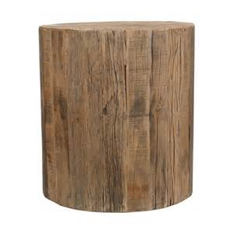](https://www.bing.com/images/search?q=houten+boomstam&view=detailv2&&id=D97D140C3F7B5E9DA004D7598460F802308FA989&selectedIndex=5&ccid=BbS0AeXA&simid=608034093015698220&thid=OIP.M05b4b401e5c047e0ae7b37465b70808co0)

C. Houten boomstam.

C. Houten boomstam.

Stijlfigurenkwartet

pleonasme

[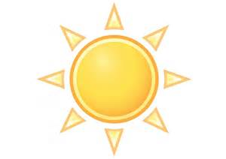](https://www.bing.com/images/search?q=zon&view=detailv2&&id=C450C2944AA6B5B1FF8A2BEDB73AEFB9C047D27E&selectedIndex=9&ccid=CnKM4ktu&simid=608004401905076606&thid=OIP.M0a728ce24b6e172513f8b2f5a2866212o0)

D. Hete zon

Stijlfigurenkwartet

pleonasme

[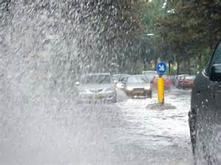](https://www.bing.com/images/search?q=hoosbui&view=detailv2&&id=0B986740E54834D9D7B3C2A9FD19C1E0850449E3&selectedIndex=0&ccid=6fj4NwgJ&simid=607990709553660928&thid=OIP.Me9f8f83708095da7be63d01049086135o0)

B. Natte regen.

Stijlfigurenkwartet

pleonasme

Overbodige toevoeging (bijv.nw/zelfst.nw).

[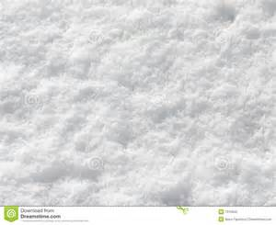](https://www.bing.com/images/search?q=witte+sneeuw&view=detailv2&&id=BFD7635F2FCF5734F4284348125F3256589DD86C&selectedIndex=8&ccid=QaLmCQgO&simid=607996877133447515&thid=OIP.M41a2e609080ef08a72e5eb21bbfadae0o0)

A. Witte sneeuw.